

**University Institute of Information Technology,**

**PMAS-Arid Agriculture University,**

**Rawalpindi Pakistan**

**Project Name**

Mood base Song Recommender System

***By***

**Ahsan ali 16-ARID-1144**

**Ahmed Saleem 16-ARID-4554**

**Hassan Mehboob khan 16-ARID-4555**

***Supervisor*Mr. Zeeshan Jawed**

***Bachelor of Science in Information Technology (2016-2021)***

**The candidate confirms that the work submitted is their own and appropriate  
 credit has been given where reference has been made to the work of others**.

**DECLARATION**

We hereby declare that this software, neither whole nor as a part has been copied out from any source. It is further declared that we have developed this software documentation and accompanied report entirely on the basis of our personal efforts. If any part of this project is proved to be copied out from any source or found to be reproduction of some other. We will stand by the consequences. No Portion of the work presented has been submitted of any application for any other degree or qualification of this or any other university or institute of learning.

Ahsan Ali Ahmed Saleem Hasan Khan

--------------------------- --------------------------- ---------------------------

**CERTIFICATE OF APPROVAL**

It is to certify that the final year project of BS (it)“**Mood base Song Recommender System** ” was developed by“ **Ahsan Ali, Registration 16-ARID-1144”**, “**Ahmed Saleem, Registration 16-ARID-4554”**and “**Hasan Mehboob khan, Registration 16-ARID-4555”**under the supervision of“ **Mr. Zeeshan Javed** ” and that in their opinion; it is fully adequate, in scope and quality for the degree of Bachelors of Science in Information Technology.

---------------------------------------

**Supervisor**

---------------------------------------

**External Examiner (If any)**

---------------------------------------

**Administrator UIIT**

**Executive Summary**

In public places, there is often a need for monitoring people and different activities going on, which can be referred later for many reasons including security. Appointing humans for this task involves many problems such as increased employee hiring, accuracy problem, trust, no proof for later use, and also the fact that a human can remember things till a certain time limit. Talking about the current security system, they use dumb still cameras with a continuous recording facility ir-respective of the fact that any event may happen or not. Moreover they are usually pointing at a specific user defined locations so more than one cameras are required to cover the entire region.

To prevent all these problems from prevailing, the CSCS is developed. It is a surveillance system, which provides solution to many of these problems. It is a stand-alone application which doesn’t require any computer to operate. It monitors different situations using a camera which is able to rotate intelligently based on sensor messages and captures the scene in the form of video or photos later reference as well.

**C**ustomizable **S**urveillance **C**ontrol **S**ystem **(CSCS)** is a surveillance system that can be assigned a sensor type as in our case a heat sensor is used, it works accordingly, rotates the camera upon event detection and perform user defined actions like capturing video and stores them, for the future use.

It is an embedded system consisting of Linux fox kit with embedded a running server application also a camera, USB storage device and a sensor node base station is attached with fox kit. LAN communication is used by user to download the videos and to operate the system manually.

**Acknowledgement**

All praise is to Almighty Allah who bestowed upon us a minute portion of His boundless knowledge by virtue of which we were able to accomplish this challenging task.

We are greatly indebted to our project supervisor “Dr. Kashif Sattar” and our Co-Supervisor “Dr. Tariq Ali” for personal supervision, advice, valuable guidance and completion of this project. We are deeply indebted to him/her/them for encouragement and continual help during this work.

And we are also thankful to our parents and family who have been a constant source of encouragement for us and brought us the values of honesty & hard work.

Ahsan Ali Ahmed Saleem Hasan Khan

--------------------------- --------------------------- ---------------------------

**Abbreviations**

|  |  |
| --- | --- |
| **SRS** | Software Requirement Specification |
| **PC** | Personal Computer |
|  |  |
|  |  |
|  |  |

**Table of Contents**

**Introduction 1**

* 1. Brief

We will make mood base recommender system. Our System will classify an image in to one of six emotions. The System should include an automatic face detection algorithm. The System should include techniques for extraction Of Meaningful facial features. The System should deliver a trained classifier. The System should deliver a simple GUI. The System Should recommended a song according to our Mood. The main aim of Our Project is that to come up with a solution to the face expression recognition problem by dividing it into sub problems of classifications of some specific ‘Facial Features’. For this, different methodologies and techniques for feature extraction, normalization selection and classification are considered.The resulting system comes up with solutions to these problems as well as taking the computational complexity and timing issues into consideration. In our system we transitioned a manual system into new computerized system. Different modules are will be constructed based on the requirements gathering from the stakeholder and the environment.We will use waterfall methodology and CNN model.

* 1. Relevance to Course Modules

We studied about face recognition in human computer interaction.we studied about waterfall method in software engireering.

* 1. Project Background

When we Studied We Know that The Several papers have been published in the area of face emotion recognition. And There Are A lot of Problems which occur in the Past i.e. there is a System in which human does not Listen a songs According To their Mood the Song Played Randomly and did not entertained The User. There are too many Existing Project and they All have too many Problems, We Will Solved that Problems.

* 1. Literature Review

[1] “Intelligent image recognition system for marine fouling using Softmax transfer learning and deep convolutional neural networks” volume 2017 ,  <https://doi.org/10.1155/2017/5730419>.

# [2] “Emotion Recognition of Students Based on Facial Expressions in Online Education Based on the Perspective of Computer Simulation” volume 2020 , <https://doi.org/10.1155/2020/4065207>

1. [3] **“**Effects of Facial Mood Expressions on Face Biometric Recognition System’s Reliability” Published 2018, <https://www.semanticscholar.org/paper/Effects-of-Facial-Mood-Expressions-on-Face-System%E2%80%99s-Azimi/f5f56b93585f1e18476b0cb6bd272b26fee9dd2e>.
2. [4] “Towards panshot face unlock” 5july 2013, <https://www.mayrhofer.eu.org/downloads/publications/IJPCC-2013-Mobile-Phone-Face-Detection.pdf> .
3. [5] “Linguistic-based emotion analysis and recognition for measuring Consumer satisfaction: an application of affective computing” 22august2012, <https://link.springer.com/article/10.1007/s10799-012-0138-5>
4. [6] "Emotion Recognition using Convolutional Neural Networks"2019 , <https://docs.lib.purdue.edu/purc/2019/Posters/63/> .
5. [7 ] “[A Model of the Perception of Facial Expressions of Emotion by Humans](https://www.researchgate.net/publication/318533661_A_Model_of_the_Perception_of_Facial_Expressions_of_Emotion_by_Humans_Research_Overview_and_Perspectives)”July2017, <https://www.researchgate.net/scientific-contributions/Shichuan-Du-59190432> .

# Analysis from Literature Review (in the context of your project)

# When we study about back Ground of our Project we have to know that there are too many existing Project what we’re doing in the past which have Many Problems. Some Of the Existing System were discussed below (Alex Martinez and Sichuan Du et al.,2012) have proposed a model in their study which can be used to build algorithms to understand facial expressions and emotions which will help in the study of human perceptions, interactions and disorders. Jinu Sophia in 2020 discusses Human Facial Expression Recognition using Convolutional Neural Networks” is implemented to classify human facial expressions i.e. happy, sad, surprise, fear, anger, disgust, and neutral and we addressed the task of facial expression recognition. It classified the image of faces into any of seven discrete emotion categories that represent universal human emotions and experimented with various techniques

1.5 Methodology and Software Life Cycle

We will use waterfall methodology and CNN algorithm for this project.

* + 1. Rationale behind Selected Methodology

We will use waterfall method because our project is no to much long .Our all requirements are well definied.Technology is understood and not dynamic.Through this method we will split tasks according to defined schedule.A project can proceed through the development process model phases one by one. Development moves from concept, through design, implementation, testing, installation, troubleshooting, and ends up at operation and maintenance. Each phase of development proceeds in strict order.

**Problem Definition** 6

2.1 Purpose : The problem statement of our project is that a lot Of Problems which occur In Emotion recognition and a lot of work has been done in the past. The Problem Which Our Software Solved is that to extract and determine the emotion of a user, we need to extract features from an image and use them against a trained data set to classify the input and determine the emotion. In this project we will use a CNN model which can classify six facial emotions (Anger, Disgust, Fear, Happiness, Sadness and Surprise) with high degree of accuracy. We will develop this type of System because now a days People tired due to Overwork and this type of system will satisfy their mind and they feel relaxed Once a song was selected doesn’t mean that next song will be of same category or mood. Every time we required to select songs according to our mood from the playlist. So, that it was time consuming as well as irritating too. For this reason, there should be an applicaon that will play music according to our mood and will take less time consuming and easy to handle. We Work On front end And Back end tools these are The Skills which we will learn from this Project. 7

2.2 Product Functions : in product function our project design will be simple and easy to use by the customer and make easy buttons to understand by customer simply these functions are given below

**Open camera:**

Event: When user click, the open camera button will call the function “OpenCamera ()” which open the camera and display user on interface.

**Name:** OpencameraButton

**Text:** Open Camera

• **Open file:** Event: When user click, the open file button will call the function “OpenFile ()” which open the file Dialog for User to choose an image from the directory.

**Name:** OpenfileButton

**Text:** Open File

• **Capture image:** Event: When user click, the Capture camera button will call the function “CaptureImage ()” which capture the image and display user on interface.

**Name:** CaptureImageButtton

**Text:** Capture Image

• **Create playlist:** Event: when user click, create playlist button will call the function “CreatePlaylist ()” which creates playlist for the mood, which have been predicted from the image and display user on interface.

**Name:** CreatePlaylistButton

**Text:** Create Playlist

• **Close:** Event: when user click, close button will call the function “Close ()” which removes the current window.

**Name:** CloseButton

• **Play Button:** Event: When user wants to Play Music, he will click the play button with showing Play icon which call the function PlayMusin() and system will select a mucis from music list and play it.

**Name:** PlayButton Icon: “Icons/play.png”

• **Stop Button:** Event: When user wants to Stop Music, he will click the Stop button with showing Stop icon which call the function StopMusic() and system will Stop a mucis. **Name:** StopButton Icon: “Icons/stop.png”

• **Pause button:** Event: When user wants to stop the music, clicks the pause button which calls the function “PauseButton”.

**Name:** Pause Button Icon: "Icons/play.png"

• **Next button:** Event: Typically displaying an arrow pointing to right, on click next icon call the function “NextButton ()” which may be selected in order to play the next music. **Icon:** “Icons/Next.png”

**Name:** PreviousButton

• **Previous button:**

**Event:** Typically displaying an arrow pointing to the left, on click previous icon call the function “previousButton ()” to Play the previous music.

**Icon:** "Icons/Previous.png"

**Name:** PreviousButton

• **Music slider: Event:** Moving music slider left to right will call the function “musicSlider()” is used to move along in continuous contact with smooth or slippery surface to change the music duration.

**Name:** MusicSlider

• **Volume slider:** Event: When user wants to high and low volume, he will move the volume slider left or right to increase or decrease the volume.

**Name**: VolumeSlider

• **Menu: Event:** Menu bar is a dropdown list used to choose the “Update Dataset” and “Update Model” options.

**Name:”** menuMenu” text: “Menu”

• **Update Dataset**

Update dataset button in use to update the dataset for our model to train the model according to user wish.

• **Update Model**

Update Model button in use to update the model or train the model on user dataset.

• **Playlist viewer:** The playlist viewer is the small window used to view the playlist after prediction of mood.

• **Image Viewer:** Image Viewer is the small window in which the image captured from the camera or chosen from the directory is displayed after prediction on the face.

2.3 Proposed Architecture

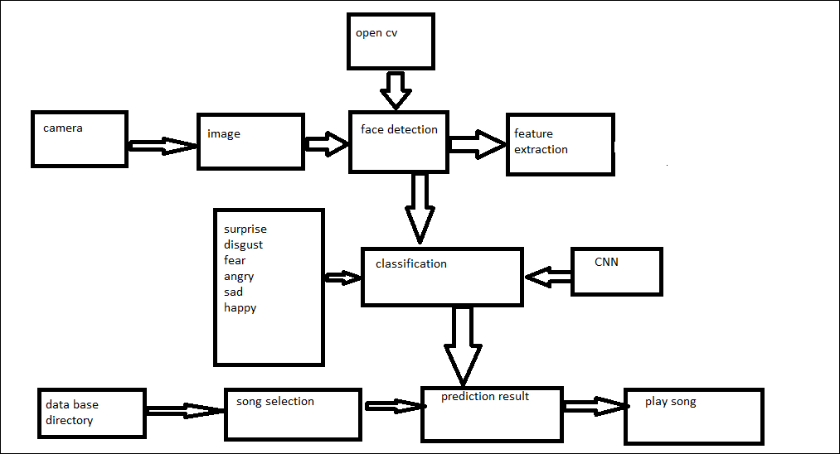

2.4 Project Deliverables : our project is that we will make basically “ mood base song recomender system” Our project scope is that we will Make Basically Mood Base recommender System. Our System should classify an image in to one of six emotions. The System should include an automatic face detection algorithm. The System should include techniques for extraction Of Meaningful facial features. The System should deliver a trained classifier. The System should deliver a simple GUI. We have 3 member is our project each member divide their work to fullfill their responsibilities and deliver their project to the customer in proper time.

as discuss in above we divide our work in each member , to make the front GUI we download QT designer and make each button in QT designer and the back end coding will be separate because of easy to use by the customer and fulfill their requirements according to the needs of customer.

at the end we see that we have to fulfill their requirement by the customer we should deliver a train classifier and deliver our product in proper time.

2.5 Operating Environment : The system is only compatible for the Windows Platform. Since we are using powerful tools i.e. Anaconda and QT Designer therefore the system on which whole installed must be at least single core 2 GHZ. like Core I5, processor 2.5 GHz and 8GB ram in PCs which are easy for every one.

Tools: Anaconda, QT designer, MS word,

2.6 Assumptions and Dependencies

When project begins, assumptions must be defined for one or more of elements:

Our project member’s availability in their desired time do Proper Work on time

Our project member’s performance

Our project member’s skills

Budget limitations in which We Complete our Project

**Requirement Analysis** 9

3.1 Functional Requirments

* + **Title:** open camera
  + **Description:** User Click on Open Camera for His expression**.**
  + **Input:** user Click on open camera to View their Image/Face Expression.
  + **Output:** Image Will be Displayed
  + **Pre-condition:** Front GUI Will be Displayed
  + **Post Condition:** Image With Expression Will Displayed
* **Title:** capture image
* **Description:** capture the image
* **Input:** camera will capture the image.
* **Output:** image Will be Displayed
* **Pre-Condition:** Image With Expression Will Displayed.
* **Post-Condition**: front GUI will display
* **Title:** Face Detection
* **Description:** user face Expressions Will Detect through Technique and Algorithm.
* **Input:** Expressions will be detected in Camera.
* **Output:** Detected image will be checked that whether this image is From Feature Extraction Are Not.
* **Pre-condition**: Image with expression is displayed on camera.
* **Post-condition**: Image or Expression of user With Detected face will be displayed.
* **Title:** Feature Extraction**.**
* **Description:** Feature extraction Will classified Expression through CNN Model.
* **Input:** Expressions will be checked Through CNN model.
* **Output:** Detected face with expression is ready For Result.
* **Pre-condition:** image or expression of user with detected face.
* **Post-condition**: image or expression of user with detected face and Facial expression will classified Through CNN model Will be Displayed.
* **Title:** Create playlist:
* **Description:** Song will recommend in Create playlist.
* **Input:** It will predict result/songs According to user mood.
* **Output:** Songs in database Directory Will be Displayed and Played.
* **Pre-condition:** image or expression of user with detected face.
* **Post-condition:** Songs will be played According to user expression.

3.2 Non – Functional Requirments

* **Title:** webcam
* **Description**: to detect/scan face
* **Input:** to detect face in webcam
* **Output:** detected face open in camera
* **Pre-condition:** front GUI will be display
* **Post-condition:** your face/expression is on camera will be detected

* **Title:** face detection algorithm
* **Description:** this is a technique/algorithm which is used or detection of face expression.
* **Input**: there is already picture in open camera face detection algorithm detect this image
* **Output:** detected image will be displayed
* **Pre-condition:** your face/expression is on camera will be detected.
* **Post-condition:** detected image/face expression will be displayed
* **Title:** recommend song
* **Description:** songs will be played according to user mood.
* **Input:** songs will be in create playlist and Will played when face detected.
* **Output:** songs will be played
* **Pre-condition:** your face/expression is on camera will be detected.
* **Post-condition:** song will be played according to user mood in create playlist.
* **Title**: close button
* **Description**: Close button will move you again in front GUI.
* **Input:** User click on close button
* **Output**: Main front GUI will be show.
* **Pre-condition**: create playlist song will be display
* **Post-condition:** Song will Played. When user click on close button front GUI will be shown**.**

3.2.1 Usability

The System Will Easy to Use. The Mood Base Recommender System Has a Simple GUI Which is Menu Based and Has All the Component Arranged logically So that User Of The System Will Not Have Any Problem In Handling The System. User Just Clicked on Open camera his face was detected in camera and Songs is recommended in Create Playlist According to his mood. The Overall Experience Of the Usage Will Be Satisfactory**.**

3.2.2 Reliability

As the System is a Desktop Application So it will run as user wants it to Run the user of the System Will Not have Any Problem in handling the system All button will made in Qt designer which is easy to use So System Will be Reliable

3.2.3 Performance

The Mood base Recommender System has a simple GUI, so that the users of the system will not have any problem in handling the system. The overall experience of the usage will be satisfactory.

3.2.4 Supportability

In Supportability first of all We test Our Project we test All of 6 emotions whter they work or not, after Testing All of these emotions we have to check whether our Software is adaptable for The user, we also check maintainablity compatibility of the final Product, The MBRS has a simple GUI, so that the users of the system will not have any problem in handling the system. The overall experience of the usage will be satisfactory.

3.2.5 Design Constraints

we dont have any hard delivery date and limits on available resources both human and hardware therefore the quality will not be suffered in designed constraints we have delivered our MBRS, transitioned a manual system into new computerized system using Anaconda and QT Designer tools. The system classified an image into one of 6 emotions. It includes an automatic face detection algorithm, techniques for extraction of meaningful facial features, delivers a trained classifier, and delivers a simple GUI. This system delivering the accuracy and prediction of models.

3.2.6 Licensing Requirements

will be used when needed.

3.3 Use case Model 12

3.3.1 Use Case Diagarm

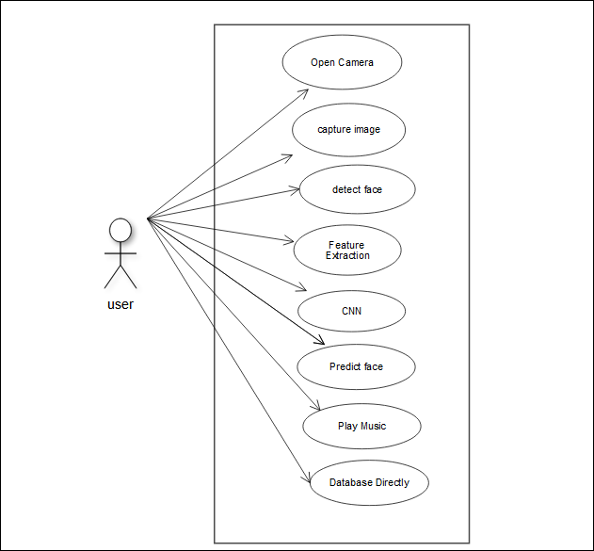

3.3.2 Actors Discription

Open camera

|  |  |
| --- | --- |
| use case ID | UC-1 |
| use case name | open camera |
| actor | user |
| description | open camera of the system |
| main path | take image of user |
| alternative | none |

Open file

|  |  |  |
| --- | --- | --- |
| use case ID | UC-2 |  |
| use case name | open file |  |
| actor | user |  |
| description | open the file dilog box for selecting user image |  |
| main path | tae image of user |  |
| alternative | none |  |

Detect face

|  |  |  |
| --- | --- | --- |
| use case ID | UC-3 |  |
| use case name | detect face |  |
| actor | user |  |
| description | take a picture of user through camera |  |
| main path | take image of user |  |
| alternative | none |  |

Feature extraction

|  |  |  |
| --- | --- | --- |
| use case ID | UC-4 |  |
| use case name | feature extraction |  |
| actor | system |  |
| description | apply feature extraction technique on capture image to enhance user image |  |
| main path | enhance user image |  |
| alternative | none |  |

Perform testing

|  |  |  |
| --- | --- | --- |
| use case ID | UC-5 |  |
| use case name | perform testing |  |
| actor | system |  |
| description | run the user image on CNN model to make some prediction |  |
| main path | classify into some category |  |
| alternative | none |  |

play music

|  |  |  |
| --- | --- | --- |
| use case ID | UC-6 |  |
| use case name | play music |  |
| actor | system |  |
| description | play music for user acording to his mood predicted by CNN model |  |
| main path | take music from directory and play it |  |
| alternative | none |  |

3.3.3 Use Case Discription

**Open Camera**

User will click on the “Open Camera” button from the system interface and system will process and open system camera for user.

**Open File**

User will click on the “Open Camera” button from the system interface and system will process and open system camera for user.

**Detect Face**

After the Camera of system is open user will click the button “Capture image”. The system will process and take a pic of user through camera and give feedback.

**Feature Extraction**

After taking image of user system will automatically apply sum feature Extraction Techniques and enhance the image quality and give feedback to user.

**Perform Testing**

After Enhancement of user image system will automatically run the image on the trained CNN model which predict the mood type of user.

**Play Music**

After the prediction from model the System will take a music from database by comparing the predicted category to the category in database and play that song for user.

**The Design** 21

4.1 UML Structural Diagrams 22

4.1.1 Component Diagram 22

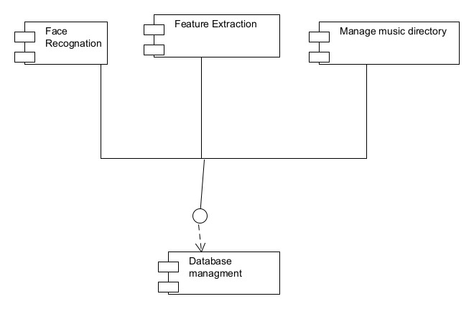

4.1.2 System Component Diagram 24

4.1.3 Package Diagram 25

4.1.4 Deployment Diagram 26

4.2 UML Behavioral Diagrams 27

4.2.1 Activity Diagrams 27

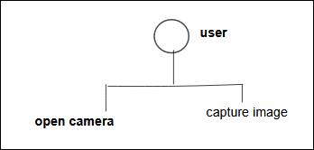

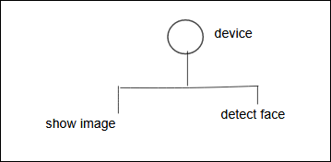

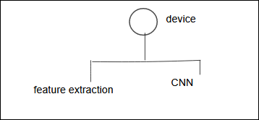

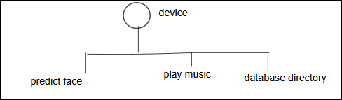

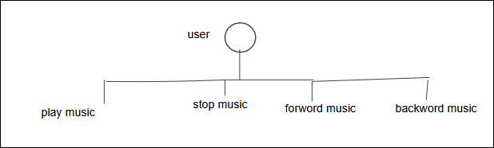

4.2.2 State Machine Diagrams 29

4.3 UML Interaction Diagrams 30

4.3.1 Sequence Diagrams 30

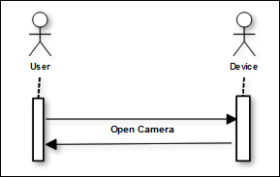

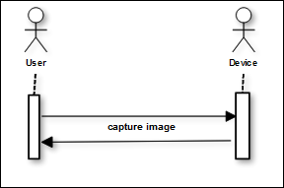

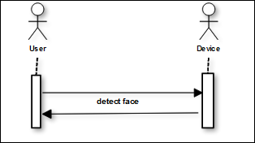

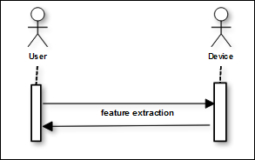

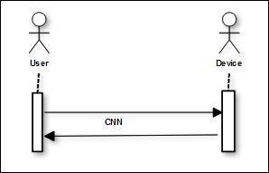

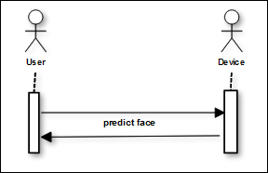

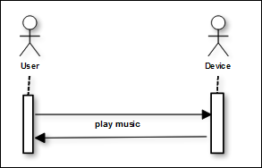

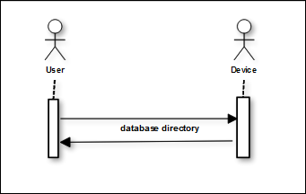

4.4 Node Structure 31

4.5 Communication Design Protocol 32

**Implementation** 33

# Language

# Python

# Libraries

* pip install tensor flow
* pip install keras
* pip install open cv
* pip install pyqt5
* pip install pyqt5-tools
* pip install import_ipynb

# Tool

* Anaconda
* QT designer
* MS word

# User Interface

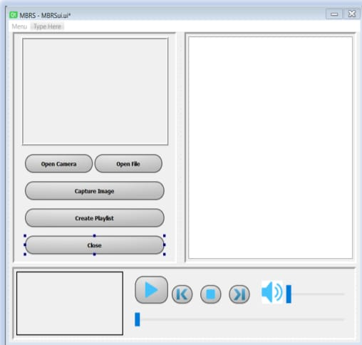

**Testing and Evaluation**

6.1 Module/Unit Testing

### Test Case Name: open camera

|  |  |  |
| --- | --- | --- |
| |  | | --- | | **Project Name:** Mood base song recommendation system | | **Test Case: 1** | |
| **Test Case ID:** T_01 |
| **Test Priority (Low/Medium/High):** High |
| **Module Name:** open camera |
| **Input:** user Click on open camera to View their Image/Face Expression.. |
| **Test Title:** if one button work then we move onward. |
| **Description:** . Open the camera of the system |
| **Pre-Condition:** front GUI will be displayed |

### Test Case Name: capture image

|  |  |  |
| --- | --- | --- |
| |  | | --- | | **Project Name:** Mood base song recommendation system | | **Test Case: 2** | |
| **Test Case ID:** T_02 |
| **Test Priority (Low/Medium/High):** High |
| **Module Name:** capture image |
| **Input:** camera will capture the image. |
| **Test Title:** if one button work then we move onward. |
| **Description:** Open the camera for capture user image. |
| **Pre-Condition:** image with expression will be displayed |

### Test Case Name: detect face

|  |  |  |
| --- | --- | --- |
| |  | | --- | | **Project Name:** Mood base song recommendation system | | **Test Case: 3** | |
| **Test Case ID:** T_03 |
| **Test Priority (Low/Medium/High):** High |
| **Module Name:** detect face |
| **Input:** expression will be detected in camera. |
| **Test Title:** if one button work then we move onward. |
| **Description:** . Take a picture of user through camera. |
| **Pre-Condition:** image with expression is displayed on camera |

### Test Case Name: feature extraction

|  |  |  |
| --- | --- | --- |
| |  | | --- | | **Project Name:** Mood base song recommendation system | | **Test Case: 4** | |
| **Test Case ID:** T_04 |
| **Test Priority (Low/Medium/High):** High |
| **Module Name:** feature extraction |
| **Input:** expression will be check through CNN model. |
| **Test Title:** if one button work then we move onward. |
| **Description:** feature extraction will classified expression through CNN model. |
| **Pre-Condition:** image or expression of user with detected face |

### Test Case Name: create playlist

|  |  |  |
| --- | --- | --- |
| |  | | --- | | **Project Name:** Mood base song recommendation system | | **Test Case: 5** | |
| **Test Case ID:** T_05 |
| **Test Priority (Low/Medium/High):** High |
| **Module Name:** create playlist |
| **Input:** it will predict result/songs according to user mode. |
| **Test Title:** if one button work then we move onward. |
| **Description:** song will recommend in create playlist. |
| **Pre-Condition:** image or expression of user with detected faces |

### Test Case Name: play music

|  |  |  |
| --- | --- | --- |
| |  | | --- | | **Project Name:** Mood base song recommendation system | | **Test Case: 6** | |
| **Test Case ID:** T_06 |
| **Test Priority (Low/Medium/High):** High |
| **Module Name:** play music |
| **Input:** take music from directory. |
| **Test Title:** if one button work then we move onward. |
| **Description:** Play music for User according to his mood predicted by CNN model. |
| **Pre-Condition:** all songs must be show after reading our face expression |

# Chapter 7: Conclusion and Future Work

This chapter concludes the project and highlights future work.

# Conclusion

basically our milestone is to recommend song by using facial expression then we search to know about CNN model then we take facial expression in CNN model and our system give 55 to 60% correct output but in future we try more and more to add minor facial expression in our project, we think we can recommend song by using facial expression.

# Future Work

in our project we have a lot of facial expression but we are try to copy every minor expression and then show output, in CNN model we use six facial expression but we can try to allow more facial expression and the increment of coding and then system can shoe more output.